Sample Letter: Female Sterilization

Sample Letter: Female Sterilization (Bilateral Salpingectomy)

[NAME]
[ADDRESS]

[DATE]

To Whom It May Concern:

I am enrolled in an [INSURANCE COMPANY NAME] plan, policy number [POLICY NUMBER]. My health care provider [HAS PERFORMED/WILL PERFORM] a Bilateral Salpingectomy on [DATE]. This procedure was recommended in consultation with my health care provider based on my health needs. The Patient Protection and Affordable Care Act requires that my insurance provide coverage of this sterilization procedure with no cost sharing, however [I have been asked to pay a [CO-PAY/DEDUCTIBLE/CO-INSURANCE] for this procedure] OR [I have been told that [COMPANY NAME] will not provide coverage of this this procedure without cost sharing].

Under § 1001 of the Patient Protection and Affordable Care Act (ACA), which amends § 2713 of the Public Health Services Act, all non-grandfathered group health plans and health insurance issuers offering group or individual coverage shall provide coverage of and not impose cost sharing for certain preventive services for women. The list of women’s preventive services which must be covered in plan years starting after Aug. 1, 2012. Department guidance released on January 10, 2022, confirms that preventive service coverage includes “the full range of U.S. Food and Drug Administration (FDA)-approved, -granted, or -cleared contraceptives, effective family planning practices, and sterilization procedures be available as part of contraceptive care. Additionally, contraceptive care includes “screening, education, counseling, and provision of contraceptives (including in the immediate postpartum period),” as well as, “follow-up care (e.g., management, evaluation, and changes, including the removal, continuation, and discontinuation of contraceptives), sterilization procedures, and patient education and counseling for all women with reproductive capacity.” (http://www.hrsa.gov/womensguidelines/). These methods are listed in the Food and Drug Administration’s “Birth Control Guide,” but also extends to any additional contraceptives approved, granted, or cleared by the FDA. (Attached) My health insurance plan is non-grandfathered. Thus, the plan must comply with the women’s preventive services requirement.

Specifically, the plan must provide coverage without cost sharing of the sterilization procedure which my provider [HAS PERFORMED/WILL PERFORM]. The ACA requires plans to provide coverage without cost sharing of all FDA approved contraceptive methods and sterilization procedures. Furthermore, the Departments of Labor, HHS and the Treasury notes that “if an individual’s attending provider recommends a particular service or FDA-approved item based on a determination of medical necessity with respect to that individual, the plan or issuer must cover that service or item without cost sharing. Thus, a plan or issuer must defer to the determination of the attending provider.

[INCLUDE IF EXPERIENCING ISSUES WITH BILLING CODES]
According to conversations with representatives from [PLAN/ISSUER NAME] [IF AVAILABLE, include information received from plan/issuer], I am being billed for out-of-pocket costs because [PLAN/ISSUER NAME] claims that CPT/HCPCS Code [BILLING CODE USED FOR SERVICE] is not a preventive services code, and therefore, is not subject to the ACA’s birth control coverage requirement. However, according to the Women’s Preventive Services Initiative (WPSI) – launched by the American College of Obstetricians and Gynecologists (ACOG) and tasked with developing recommendations for women’s preventive health care services – the billing code used for my bilateral salpingectomy procedure should be covered as a preventive service and subject to zero out-of-pocket costs. I have included a screenshot of the preventive codes for your reference.

The WPSI Coding Guide (link included below) also provides that Modifier 33 is used to indicate preventive services that are not subjected to cost sharing. Based on the descriptor, and WPSI’s recommendations, [PLAN/ISSUER NAME] should either cover the preventive service, or include the modifier to ensure my surgery is not subject to cost-sharing. The descriptor for modifier 33 reads:

Preventive services: When the primary purpose of the service is the delivery of an evidence-based service in accordance with a U.S. Preventive Services Task Force A or B recommendation in effect and other preventive services identified in preventive services mandates (legislative or regulatory), the service may be identified by adding 33 to the procedure. For separately reported services specifically identified as a preventive, the modifier should not be used.

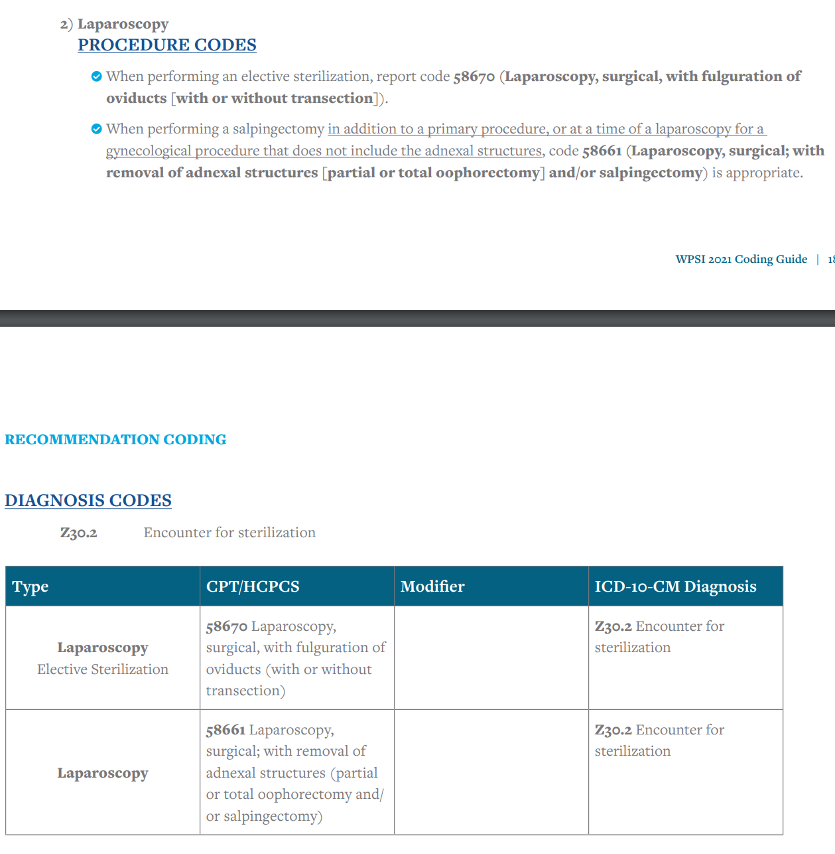

LAST PARAGRAPH OPTIONS:
(1)
I have spent [TOTAL AMOUNT] out of pocket on my bilateral salpingectomy, even though it should have been covered without cost sharing. I have attached copies of receipts which document these out-of-pocket expenses. I expect that [COMPANY NAME] will rectify this situation by ensuring that my procedure is covered by my plan without cost sharing in the future, reimbursing me for the out of pocket costs I have incurred during the period it was not covered without cost sharing, and changing any corporate policies that do not comply with the Affordable Care Act.

(2)
My health care provider is prepared to perform the Bilateral Salpingectomy when [COMPANY NAME] assures that I have coverage without cost sharing. I expect that [COMPANY NAME] will rectify this situation and notify me within 30 days of receipt of this letter that my preventive health procedure will be covered without cost sharing.

Sincerely,

[YOUR SIGNATURE]

Encl:
FDA Birth Control Guide (available at: https://www.fda.gov/media/150299/download)

Frequently Asked Questions about the Affordable Care Act (Part XII) (available at http://www.dol.gov/ebsa/faqs/faq-aca12.html)

Frequently Asked Questions about the Affordable Care Act (Part 51) (available at https://www.dol.gov/sites/dolgov/files/EBSA/about-ebsa/our-activities/resource-center/faqs/aca-part-51.pdf)

WPSI Coding Guide (available at: https://www.womenspreventivehealth.org/wp-content/uploads/FINAL_WPSI_CodingGuide_2021_Individual.pdf).

Copies of Receipts Documenting Out of Pocket Costs

https://www.dol.gov/sites/dolgov/files/EBSA/about-ebsa/our-activities/resource-center/faqs/aca-part-51.pdf
https://www.womenspreventivehealth.org/wp-content/uploads/FINAL_WPSI_CodingGuide_2021_Individual.pdf

