I believe we should
#InvestInKids
because
____________________
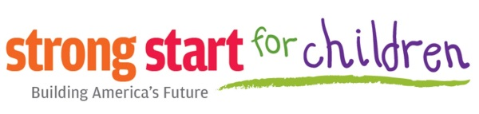
Back to School 2014

